Built for the Heavy: How Three Days Grace Powers Its Global Tour with Sennheiser EW-DX

Digital Precision and Rock-Solid RF Coordination Are Helping One of Rock’s Hardest-Working Crews Eliminate Technical Friction and Keep the Focus on the Performance

CHATHAM, Ontario, May 19, 2026 – For a high-octane rock band like Three Days Grace, the stage is a demanding environment where technical failure isn’t an option. As the band prepared for their latest record cycle and a transition to a five-piece lineup, the need for a rock-solid, high-fidelity wireless infrastructure became paramount. Leading the charge on the technical side is Jeramy “HooGie” Donais, a seasoned veteran of the touring world with nearly three decades of experience.
Having spent years maintaining the rigs for titans like Shinedown and Five Finger Death Punch, HooGie knows that in the heat of a live set, the best gear is the gear that stays out of the way. "It’s all about detail-oriented work over a long period of time," HooGie says of his approach. "With Three Days Grace, I’ve known guitarist Barry Stock for 20 years. He asked me to be in his corner because he enjoyed the work I’ve done and my calm demeanor. Two years later, here we are taking care of the rig."

The band’s relationship with Sennheiser is a long-standing tradition, but the recent tour cycle marked a significant leap forward. Moving away from legacy analog units, the production transitioned to the Sennheiser EW-DX, a cornerstone of the Evolution Wireless Digital family. "Three Days Grace has been a Sennheiser band since the beginning," HooGie explains. "When we started looking at new equipment, we found the EW-DX and it simply made sense to continue that relationship. They have made my workflow so much simpler with coordinating, monitoring, and fast tweaks — Sennheiser makes my job easy!"

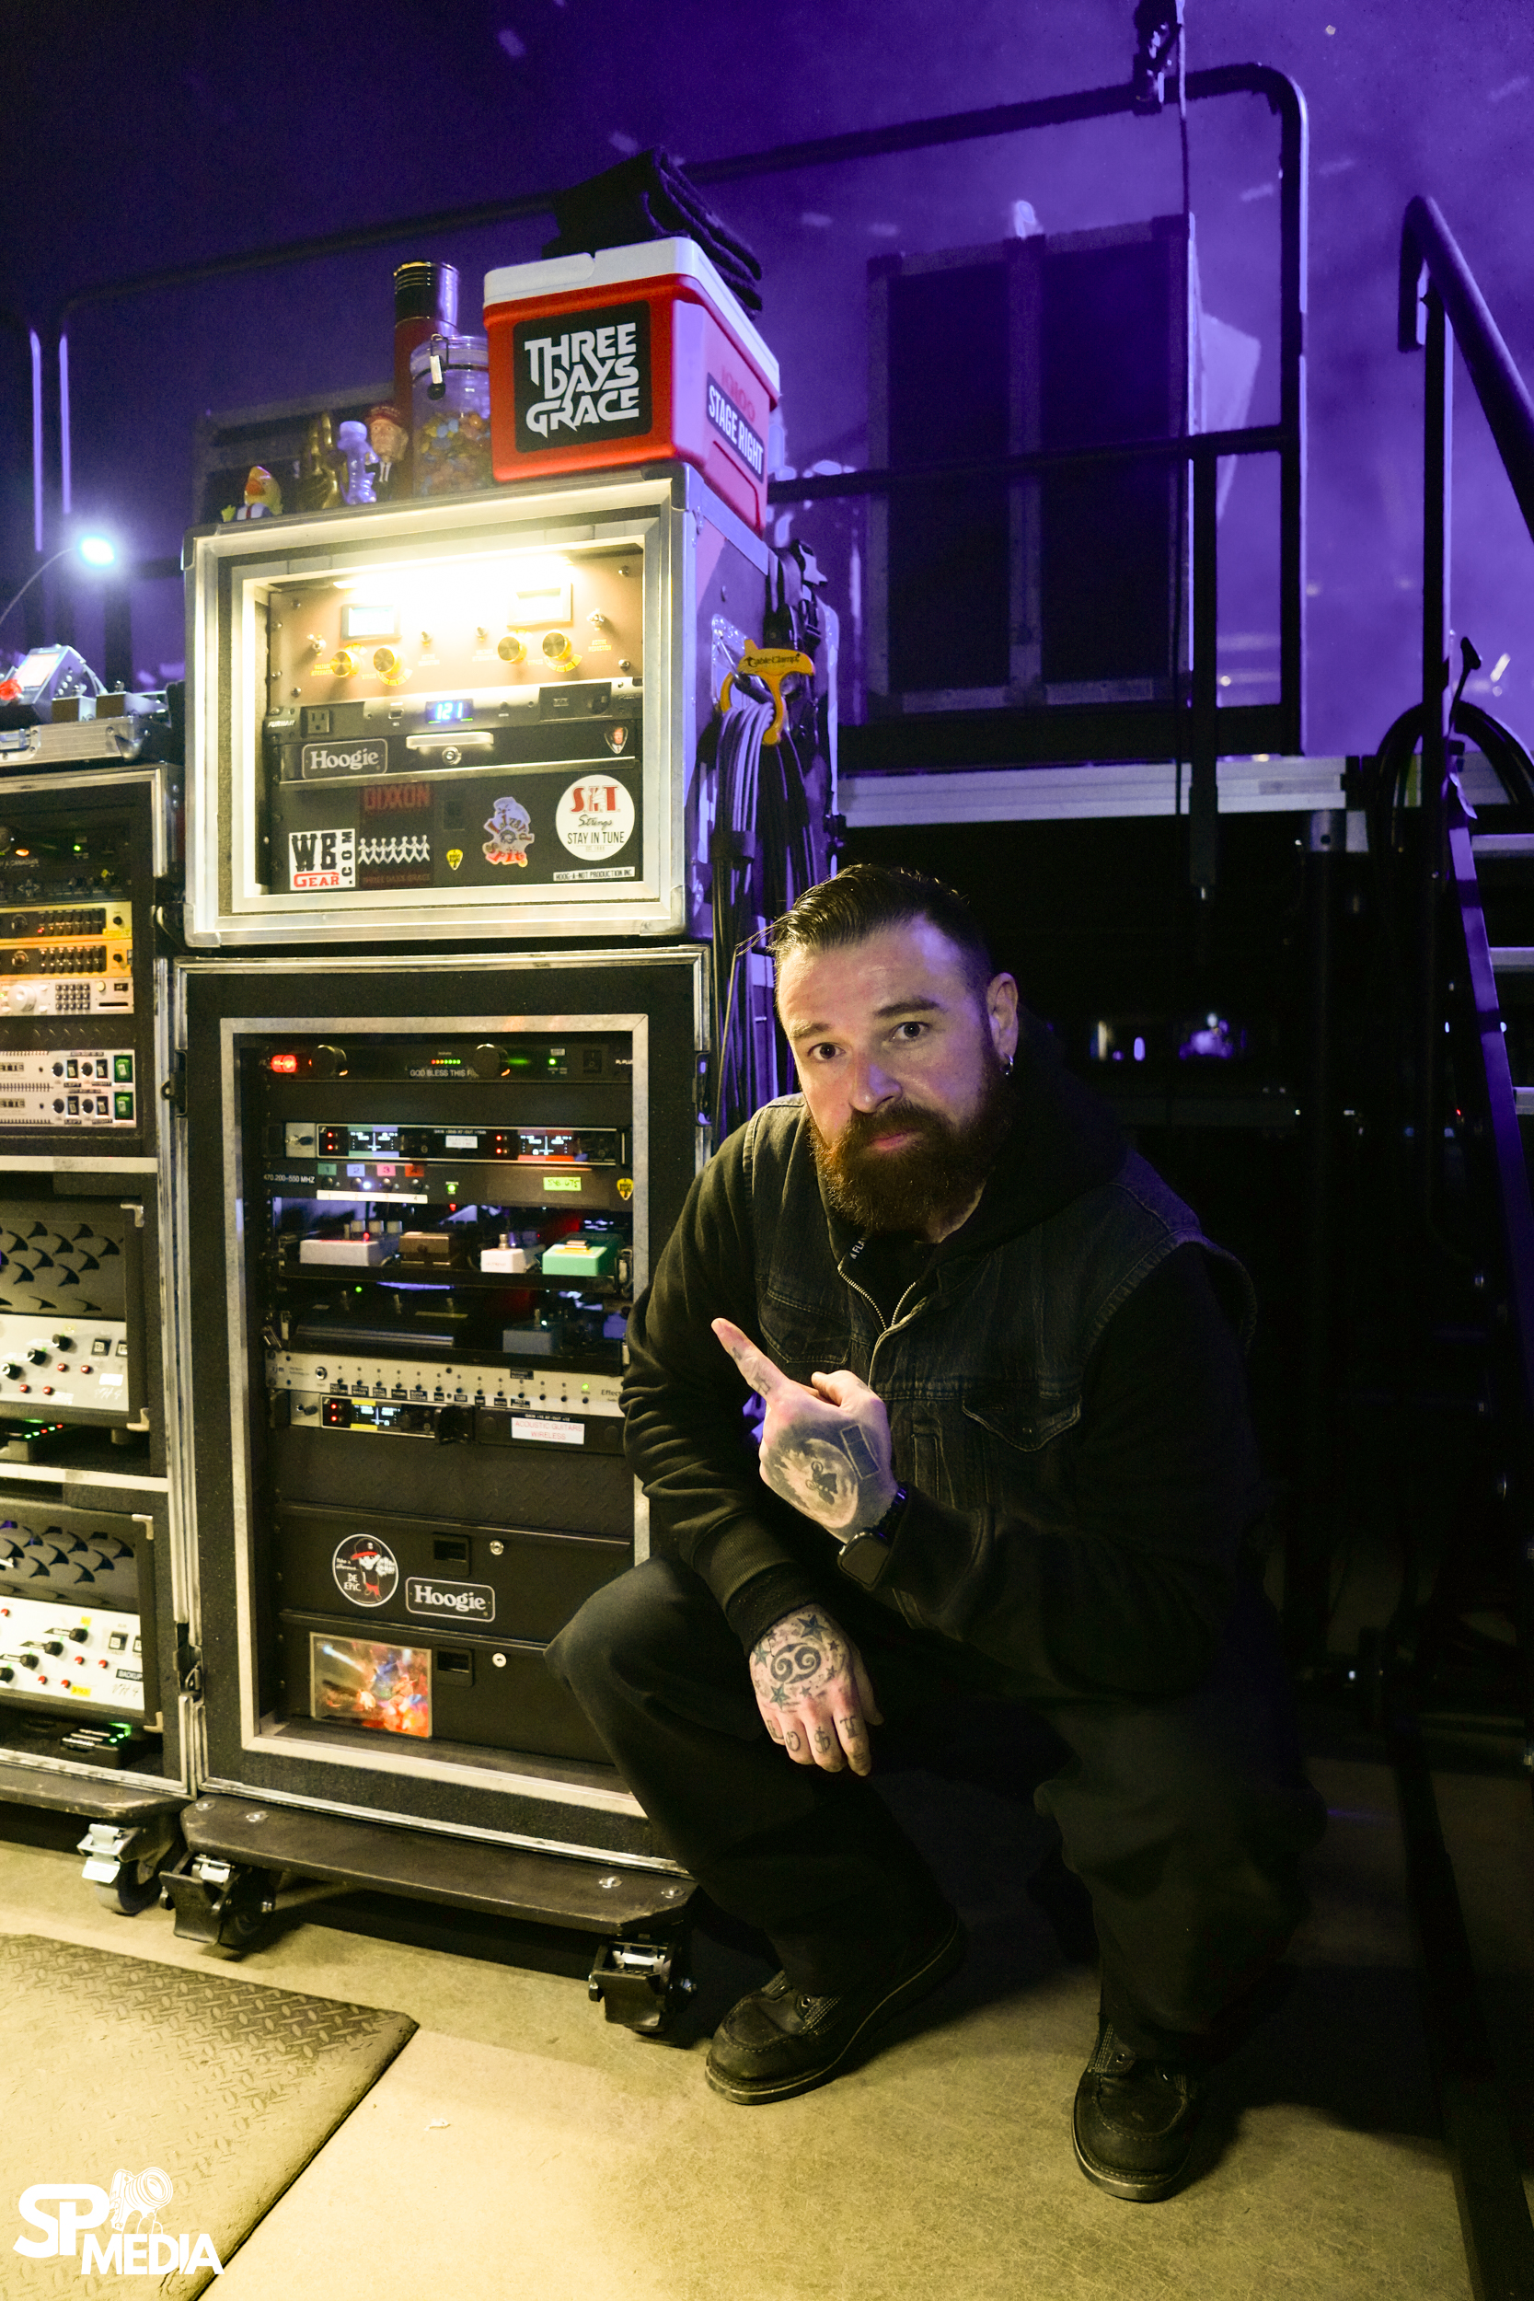
Jeramy “HooGie” Donais poses with the band’s touring rack, which features the EW-DX for streamlined workflows and high-octane performance. Photo credit: Sanjay Parikh.

For Stock, whose rig includes six wireless channels and over 20 packs, the primary concern was headroom and transparency. The EW-DX delivered immediately. With its 134 dB dynamic range and ultra-low 1.9 ms latency, the system captured the full nuance of the band’s performance — from delicate light touches to the aggressive, fast-attack playing of their high-gain sound.

"The EW-DX stays out of the way," says HooGie. "The tone and the headroom are the heart of our mission. The low end stays thick, and the pick attack stays sharp. As soon as we made the change, we noticed the difference immediately. Barry was blown away at how flawless everything sounds.”

Beyond the sonic benefits, the EW-DX has radically optimized the daily touring workflow through Bluetooth Low Energy (BLE) sync. In the past, syncing 20 wireless packs meant physically handling each unit at the rack. "To go from having to rip each pack off of a strap and go to a unit, to now being able to simply push two buttons has been a game changer," HooGie notes. "It’s saved me an hour every day. It’s way less running around combined with a cleaner, faster workflow. I now stay ahead of any problems because problems just don’t exist with the EW-DX."

This efficiency extends to frequency coordination via equidistant channel spacing, which allows HooGie to navigate "dirty" RF environments and crowded festival spectrums with ease. "The EW-DX takes a lot off your plate in regard to spacing," he says. "Instead of babysitting wireless all day long, I can just keep an eye on what my job is — keeping the rig running where it needs to be."

The physical demands of the show are equally rigorous, with 19 to 20 guitar changes occurring over a two-hour set. The metal-housed SK bodypacks have stood up to the "built like a tank" reputation required for global touring. "The show is full-on," HooGie says. "The metal pack housings have been no problem. They stay put, stay connected, and everything’s locked into place. There’s no discomfort for the band." Barry Stock agrees. “My rig is built to be as reliable as possible on stage. Everything is consistent and that starts with a good wireless system so I can focus on playing.”

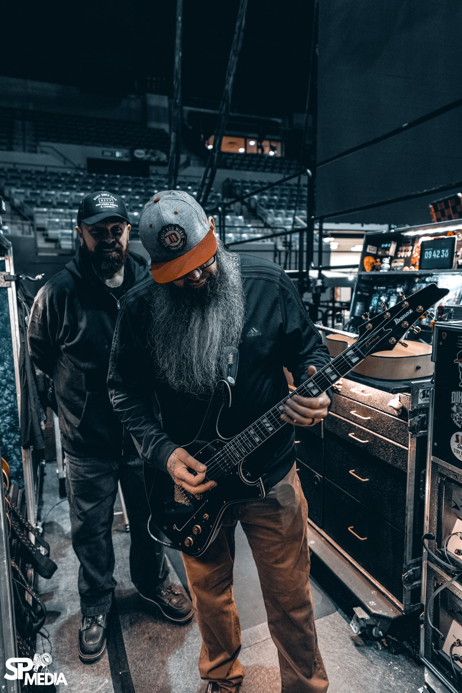
Three Days Grace members, including guitarist Barry Stock, rely on the EW-DX to deliver consistent sound in the most demanding tour environments. Photo credit: Sanjay Parikh.

As the band prepares to take this rig across North America and into 19 shows across Europe, the consistency and scalability of the EW-DX — including Dante-enabled configurations — provide a future-proof foundation. For HooGie, the system is the right tool for an intensive global schedule. "It’s nice to travel around the world and have the same piece of gear with you everywhere you go. I would honestly put it up against any of the other major systems out there. It hasn’t let me down for even a moment."

By modernizing the stage with digital precision, HooGie and the Three Days Grace crew have ensured that technical limitations never interrupt the performance. With the reliability of the EW-DX at the core of the rig, the band can continue to dominate the stage with poise, power, and the technical grace that their world-class production demands.

###

About the Sennheiser brand
We live and breathe audio. We are driven by the passion to create audio solutions that make a difference. Building the future of audio and bringing remarkable sound experiences to our customers – this is what the Sennheiser brand has represented for more than 75 years. While professional audio solutions such as microphones, meeting solutions, streaming technologies and monitoring systems are part of the business of Sennheiser electronic GmbH & Co. KG, the business with consumer devices such as headphones, soundbars and speech-enhanced hearables is operated by Sonova Holding AG under the license of Sennheiser.

www.sennheiser.com
www.sennheiser-hearing.com

Global Press Contact
Daniella Kohan
daniella.kohan@sennheiser.com
+1 (860) 227-2235

Local Press Contacts
InGear
Chloe Hildeman
chloe@ingearpr.com
+1 425-466-2264

